New World Wine Map Reveals: San Francisco Bay Vineyards Are 2.5 °C Cooler Than Those in Tuscany
The interactive map charts more than 4.3 million vineyards, 1,613 of them in the San Francisco Bay AVA.
World Winery Map, the newly launched wine map of the world, maps 331 wineries and 1,613 vineyards from the San Francisco Bay AVA. San Francisco Bay vineyards sit at an average elevation of 179 metres and are 2.5 °C cooler during the vine growing season than those in Tuscany, according to World Winery Map data.
The project is the most comprehensive interactive database of global wine terroir, mapping 4,303,693 vineyards and 104,330 wineries across 90 countries. For every single vineyard on the map, users can access highly specific geospatial data, including elevation, solar radiation, and slope, alongside critical viticultural metrics like soil composition, the Huglin index, and average temperatures during the vine growing season.
"For each parcel, we extracted the exact coordinates and calculated the elevation, slope, and aspect using the Copernicus GLO-30 terrain model, then layered climate data on top of that," said Matija Gavrilović, founder of World Winery Map. "For larger parcels, we measure up to 16 control points, which is why elevation is presented as a precise range rather than a single number. We also calculated the slope, rainfall, wind, soil type, and geology wherever data was available."
The vineyard parcels are aggregated from 38 independent sources. Twenty-two of these are official government registers. The official boundaries for the United States were taken from the AVA boundaries of the TTB (Alcohol and Tobacco Tax and Trade Bureau), digitised by the UC Davis AVA project, which defines 276 wine areas for the United States. Users can select any region to read essential facts, review borders, check average rainfall and elevation, and analyze viticultural data like the Winkler index. World Winery Map is already in touch with official bodies in several countries, with the aim of keeping the map as accurate as possible.
The map outlines 98,719 specific wine region boundaries, scaling from massive macro-regions down to individual named plots. This includes 2,815 official wine regions, subregions, and appellations, alongside 95,904 named vineyard sites. The platform is explicitly tailored for both industry professionals and wine travelers. An integrated geolocation system allows users to instantly locate nearby wineries and receive navigation instructions to the estate, regardless of where they are in the world.
Winemakers from the San Francisco Bay AVA are invited to claim their winery profiles on the platform for free. By taking ownership of their pages, producers can update tasting room hours, verify visitor policies, claim their specific vineyard parcels, and update data on planted grape varieties—actively participating in maintaining the world's most accurate and detailed wine map.

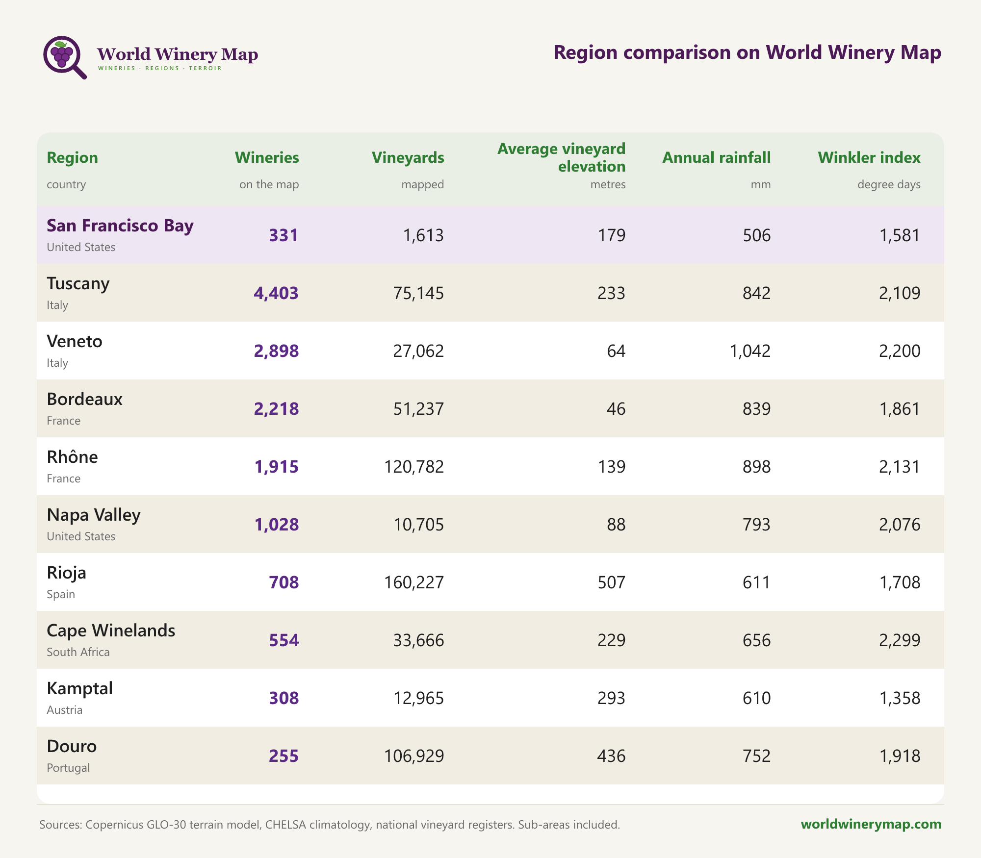
Region comparison on World Winery Map.


World Winery Map: 104,330 wineries in 90 countries.


Vineyards in Croatia. The interactive map charts more than 4.3 million vineyards across 90 countries.

